**DAYANANDA SAGAR UNIVERSITY**

**DEPARTMENT OF COMPUTER SCIENCE & ENGINEERING**

**SCHOOL OF ENGINEERING**

**DAYANANDA SAGAR UNIVERSITY**

**KUDLU GATE**

**BANGALORE - 560068**



**MINI PROJECT REPORT**

**ON**

**ONLINE NOTES SHARING PLATFORM**

**BACHELOR OF TECHNOLOGY**

**IN**

**COMPUTER SCIENCE & ENGINEERING**

***Submitted by***

**GAURAV R GOWDA -ENG17CS0075**

**ISHITHA S - ENG17CS0094**

***Under the supervision of***

**Prof. Gousia Thahniyath**

**Assistant Professor,**

**Dept of CSE,**

**Dayananda Sagar University.**

**DAYANANDA SAGAR UNIVERSITY**

**School of Engineering, Kudlu Gate, Bangalore-560068**



**CERTIFICATE**

***This is to certify that Mr./Ms. GAURAV RAMESH GOWDA, ISHITHA S bearing USN ENG17CS0075, ENG17CS0094 has satisfactorily completed his/her Major Project as prescribed by the University for the SEVENTH semester B.Tech. programme in Computer Science & Engineering during the year 2020 at the School of Engineering, Dayananda Sagar University., Bangalore.***

Date:

Signature of the faculty in-charge

|  |  |
| --- | --- |
| Max Marks | Marks Obtained |
|  |  |

Signature of Chairman

**DECLARATION**

We hereby declare that the work presented in this mini project entitled “**ONLINE NOTES SHARING PLATFORM**” submitted to **DAYANANDA SAGAR UNIVERSITY**, **Bengaluru** is a record of group work implemented under the guidance of **Prof. Gousia Thahniyath**, Assistant Professor, Department of CSE, Dayananda Sagar University.

This project is submitted in the partial fulfilment of the requirements and conductive criticism for the award of VII semester mini-project. The results embodied in this project have not been submitted elsewhere for the same.

**GAURAV R GOWDA- (ENG17CS0075)**

**ISHITHA S - (ENG17CS0094)**

**ACKNOWLEDGEMENT**

The satisfaction that accompanies the successful completion of task would be incomplete without the mention of the people who made it possible and whose constant guidance and encouragement crown all the efforts with success.

We are especially thankful to our **Chairman Dr. Sanjay Chitnis**, for providing necessary departmental facilities, moral support and encouragement.

We are very much thankful to **Prof Gousia Thahniyath**, for providing help and suggestions in completion of this mini project successfully.

We have received a great deal of guidance and co-operation from our friends and we wish to thank all that have directly or indirectly helped us in the successful completion of this project work.

**TABLE OF CONTENTS**

|  |  |
| --- | --- |
| **Contents** | **Page no** |
| INTRODUCTION | 01 |
| PROBLEM STATEMENT | 02 |
| LITREATURE SURVEY | 03 |
| METHODOLOGY | 04 |
| SOFTWARE AND HARDWARE REQUIRMENT | 05 |
| RESULTS | 06 |
| CONCLUSION | 08 |
| REFERENCES | 08 |
|  |  |

**1.INTRODUCTION**

Online Notes Sharing is a web based notes sharing and management system which helps students and teachers to share their notes online effectively. It reduces the wasting of time in manually distributing notes to each individual. It greatly overcomes the lack of availability and converts the manual old school paperwork to a fully automated and managed online system.

It allows it's users to securely register and log in to their individual accounts and create, read, update, delete notes according to their needs. It provides notes to everyone in a very secure manner. Multiple users can work in this system at the same time under centralized supervision by the administrator. It is a very useful notes management system for Colleges, Schools and other Institutes to manage and share their notes in a secure, efficient and effective manner.

**2.PROBLEM STATEMENT**

This Notes Management System can be readily used by non-programming personal avoiding human handled chance of error. This project is used by Three types of users

* Students.
* Teachers
* Administrators

Students and Teachers can create their accounts and start viewing notes shared by other users as well as upload their own notes.

Administrator is must be an authorized user who will keep track of all the uploaded notes and manage users as well through the admin panel.

New features can be added to the system as per requirements.

**3. LITERATURE SURVEY**

**ReactiveWebATN: Web-based Handwriting Note Sharing System for Distance Learning**

**Motoki Miura Faculty of Basic Sciences,**

A digital pen is an eﬀective tool for externalizing student’s thinking as handwritten notes with minimal burdens in operation. Sharing students’ thinking among the students and the teachers encourages collaborative learning. We have promoted such a learning style by implementing systems and experiments. In this paper, we describe a method and an implementation of web-based notes sharing system that can immediately update upon students’ notes drawing. By using streaming digital pens and WebSocket technologies, we have realized the real-time update of the students’ notes for a web-based application. Since the system framework is mostly based on open and standard web technologies, it is flexible and independent from particular system architecture as well as operating systems of the browsing devices.

**4.METHODOLOGY**

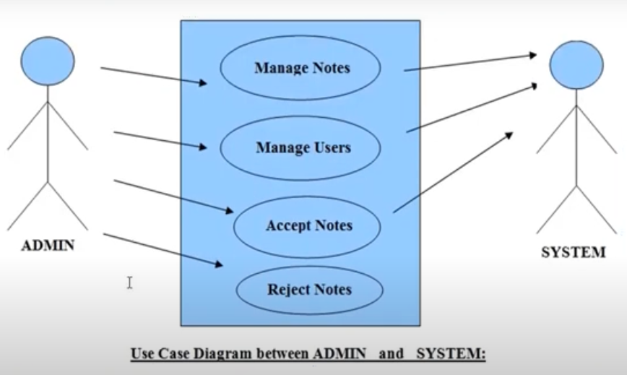

1. **SOFTWARE AND HARDWARE REQUIREMENTS**

**5.1 HARDWARE COMPONENTS**

* 4GB RAM or more
* 4GB memory or more
* Processor with clock speed 3GHx or above

**5.2 SOFTWARE REUIREMENTS**

Front end: HTML, CSS, JavaScript

1. HTML: HTML is used to create and save web documents. E.g. Notepad/Notepad++
2. CSS : (Cascading Style Sheets) Create attractive Layout
3. Bootstrap : responsive design mobile friendly site
4. JavaScript: it is a programming language, commonly used with web browsers.

Back end: PHP, MySQL

1. PHP: Hypertext Preprocessor (PHP) is a technology that allows software developers to create dynamically generated web pages, in HTML, XML, or other document types, as per client request. PHP is open source software.
2. MySQL: MySql is a database, widely used for accessing querying, updating, and managing data in databases.

.

**6.RESULTS**

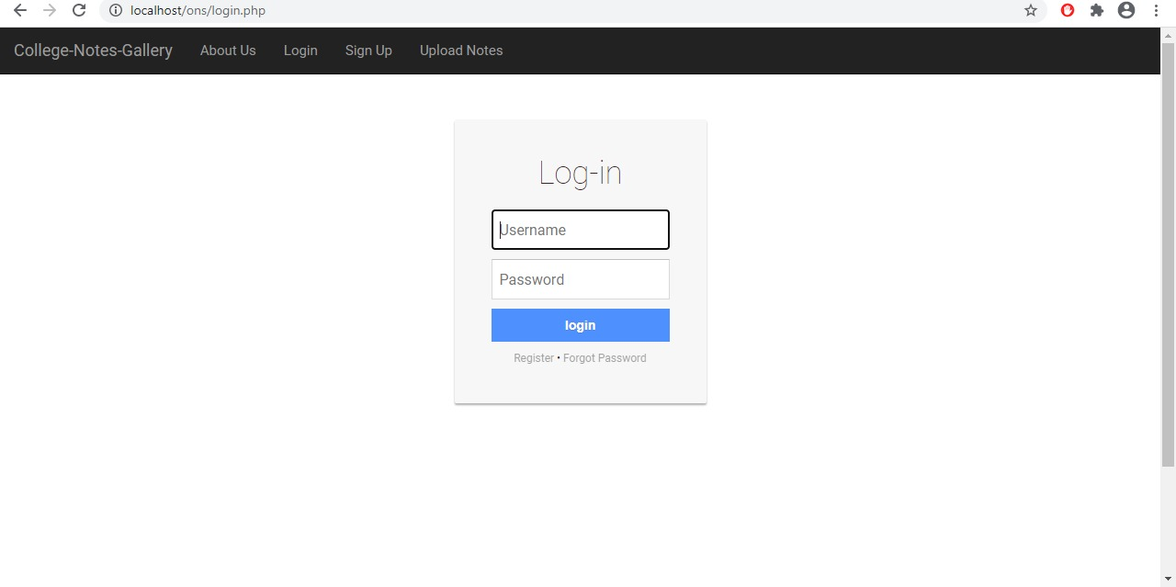

**Figure 6.1:** Admin login page

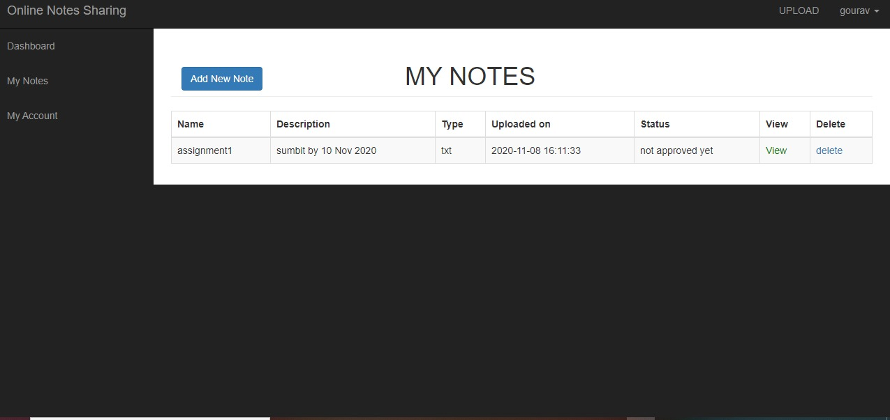

**Figure 6.2:** Adding Notes details

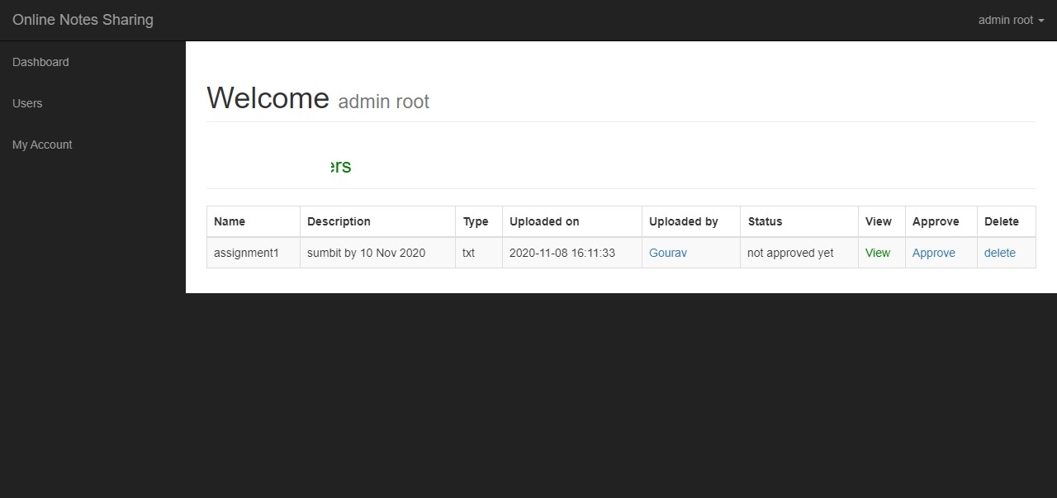

**Figure 6.3:** Notes database

**7.CONCLUSION**

This project gives me more than enough opportunity for a web-based project to design, code, measure and execute. This has helped to implement the different software engineering and database management principles Concepts such as data integrity and continuity. This has also helped me find out more about JavaScript, HTML, CSS, MYSQL, JQUERY and Personal Web Server

**8.REFERENCES**

<https://en.wikipedia.org/wiki/Web_development>

<https://simple.wikipedia.org/wiki/PHP>

[https://www.w3schools.com/php/php_mysql_intro.asp](https://www.w3schools.com/php/php_mysql_intro.asp%20)